From: http://www.strategic-culture.org/news/2017/01/15/trumps-delusion-halting-eurasian-integration-saving-us-world-order.html
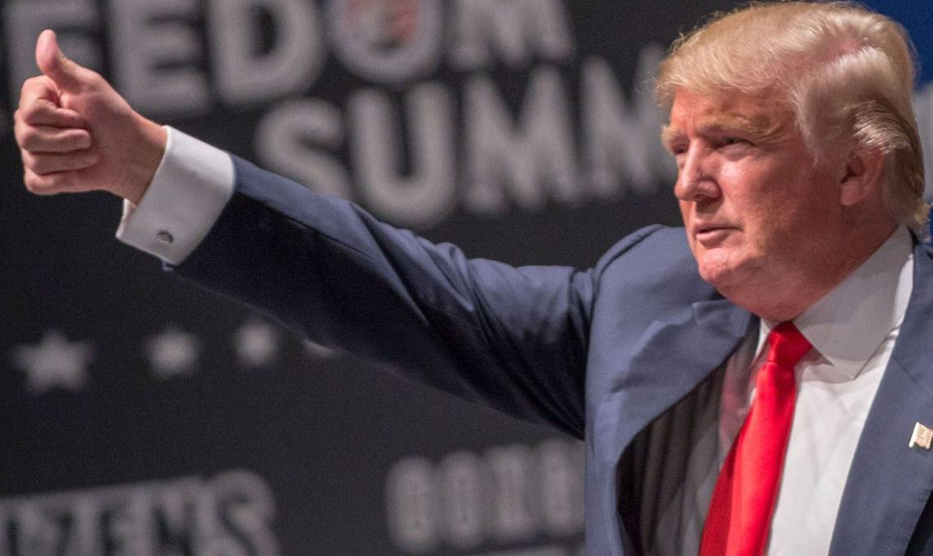
FEDERICO PIERACCINI | 15.01.2017 | OPINION

Trump's Delusion: Halting Eurasian Integration and Saving 'US World Order'
The preceding three parts of this series analyzed the mechanisms that drive great powers. The most in-depth understanding of the issues concerned the determination of the objectives and logic that accompany the expansion of an empire. Geopolitical theories, the concrete application of foreign-policy doctrines, and concrete actions that the United States employed to aspire to global dominance were examined.
Finally, the last bit of analysis focused particularly on how Iran, China and Russia have adopted over the years a variety of cultural, economic and military moves to repel the continual assault on their sovereignty by the West.
Finally, specific attention was given to the American drive for global hegemony and how this has actually accelerated the end of the 'unipolar moment', impelling the emergence of a multipolar world order.
In this fourth and final analysis I will focus on a possible strategic shift in the approach to foreign policy from Washington. The most likely hypothesis suggests that Trump intends to attempt to prevent the ongoing integration between Russia, China and Iran.
The failed foreign-policy strategy of the neoconservatives and neoliberals has served to dramatically reduce Washington's role and influence in the world. Important alliances are being forged without seeking the assent of the United States, and the world model envisioned in the early 1990s – from Bush to Kagan and all the signatories of the PNAC founding statement of principles – is increasingly coming undone. Donald Trump’s victory represents, in all likelihood, the last decisive blow to a series of foreign-policy strategies that in the end undermined the much-prized leadership of the United States. The ceasefire in Syria, reached thanks to an agreement between Turkey and Russia, notably excluded the United States.
The military, media, financial and cultural assault successfully prosecuted over decades by Washington finally seems to have met its Waterloo at the hands of the axis represented by Iran, Russia and China. The recent media successes (RT, Press TV and many alternative media), political resistance (Assad is still president of Syria), diplomatic struggles (negotiations in Syria without Washington as an intermediary) and military planning (Liberation of Aleppo from terrorists) are a result of the efforts of Iran, Russia and China. Their success in all these fields of operations are having direct consequences and implications for the internal affairs of countries like the United Kingdom and the United States.
The relentless efforts by the majority of Western political representatives for a successful model of globalization has created a parasitic system of turbo capitalism that entails a complete loss of sovereignty by America’s allies. Brexit and Trump have served as an expression of ordinary people’s rejection of these economic and political regimes under which they live.
In Syria, Washington and its puppet allies have almost exited the scene without achieving their strategic goal of removing Assad from power. Within the American political system, the establishment, spanning from Clinton to Obama, was swept away for their economic and political failures. The mainstream media, spewing an endless stream of propaganda aimed at sustaining the political elite, completely lost their battle to appear credible, reaching unprecedented peaks of partisanship and immorality.
Donald Trump has emerged with a new approach to foreign policy affairs, shaped by various political thinkers of the realist mould, such as Kenneth Waltz and John Mearsheimer. First on the to-do list is doing away with all the recent neoconservative and neoliberal policies of foreign intervention (Responsibility to Protect - R2P) and soft-power campaigns in favor of human rights. And there will be no more UN resolutions deviously employed as cover to bomb nations back into the stone age (Libya). Trump does not believe in the central role of the UN in international affairs, reaffirming this repeatedly during his campaign.
The Trump administration intends to end the policy of
- regime change,
- interference in the internal affairs of foreign governments,
- Arab Springs, and
- color revolutions.
Such efforts, they argue, are ultimately ineffective anyway and are too costly in terms of political credibility. In Ukraine the Americans have allied themselves with supporters of the Nazi Stepan Bandera, and in the Middle East they finance or indirectly support al Qaeda and al Nusra Front. These tactics, infamously branded as 'leading from behind', never achieved their desired results. The Middle East is in chaos, with a Moscow-Tehran axis emerging and going from strength to strength. In Ukraine, the government in Kiev not only seems incapable of complying with the Minsk agreements but also of prosecuting a new military campaign with no guarantees from their European and American partners.
There is a wild card that Trump hopes to play in the first months of his presidency. The strategy will focus on the inherited chaotic situation in the Middle East and Ukraine. Obama will be blamed for the previous chaos, it will be argued that sanctions against the Russian Federation should be removed, and Moscow will be given a free hand in the Middle East. In one fell swoop, the future president may decide not to decide directly on the Middle East or on Ukraine, avoiding any further involvement and instead finally making a decision in the national interest of his country.
A sustainable strategy may finally be attained by remaining passive towards the developments in the Middle East, especially on the Syrian front, leaving it firmly in Russian hands, while emphasizing at the same time the effort against Daesh in cooperation with Moscow. Another wise choice would see Kiev falling by the wayside, trashing Ukrainian ambitions to regain the Donbass and recover Crimea. Finally, removing sanctions would allow the next president to strengthen the alliance with European partners (a diplomatic necessity that Trump must make as the new president). Over two years the EU has suffered from economic suicide in the name of a failed policy strategy imposed by Washington. The Trump presidency will seek to normalize relations between Moscow and Washington as well as with European allies more willing to actively collaborate with the Trump administration.
The Middle East will accordingly see a decline in violence, increasing the chances of seeing an end to the conflict in Syria. This plan for the initial phase of the Trump presidency has been widely announced during the months leading up to his election, both by himself or by members of his staff. [really?!]
The implicit message is to seek dialogue and cooperation with all nations. Probably what lies behind these overtures is actually an explicit willingness to try to break the cooperation between Russia, Iran and China. The motivations for this action stem from the implications for the United States if a full military, cultural and economic alliance between Beijing, Moscow and Tehran is formed. It would almost ultimately consign the United States to irrelevance on the grand chessboard of international relations.
More realistically, Trump aims to shift the focus of the United States from the Atlantic to the Pacific, where the largest US commercial interests will reside in the future; a shift of focus from the Middle East to the South and East China Seas. The geopolitical reasons behind this decision, and the guiding theories behind it, were addressed particularly in the first article of this series. In summary, Trump intends to accelerate Obama’s Asian pivot, bringing about profound changes to US foreign policy. Smoking the peace pipe with Russia will free up resources (to "build up our military" in naval terms) to be focused in the Pacific. He intends to emphasize the importance of bilateral relations between allies ("free riders" Japan and South Korea) to focus on containing China.
The wildcard that Trump hopes to play in breaking the alliance is called Russia. Thanks to previous peace talks developed with Moscow, Trump hopes for a reprise of Kissinger's strategy with China in 1979, with the addition of a promise of non-interference in the Middle East against Iran and Syria by the United States. In an exchange unlikely to happen, the American administration is hoping to convince the Kremlin that no action will be taken in the Middle East against Moscow and its allies, including Iran, in exchange for help in containing the Republic of China.
With this in mind, Trump’s choice of a very questionable personality to liaise between Washington and Tel Aviv, combined with the strong rhetoric of Trump against the Islamic Republic of Iran, and the equally harsh responses from Tehran to the threats of the future president, seem to satisfy the roles and rhetoric of all parties involved. No actions, only rhetoric. For Tehran and Tel Aviv it is easier to argue that to sign an agreement. The Iranian nuclear deal will, for this reason, continue to be a major point of tension, but also the guarantor of unlikely military action.
The real problem for the future administration in this strategy is offering a consistent plan of non-interference in the Middle East. Putin is well aware, in any case, that Washington is not able to intervene and change the fate of the balance of power that is forming in the Middle East. Trump’s indirect offer not to take action in the Middle East is at best a bluff that will not last long. Trump ignores (or, being a good negotiator, pretends not to want to see) that very few cards in his deck can be attractive to Moscow. The alliance between Moscow, Beijing and Tehran is firm and certified by strategic exchanges in many fields, a trend promising tremendous growth. The war in Syria has shown the results of effective coordination between the three nations. The addition of the Islamic Republic of Iran to the Shanghai Cooperation Organization (SCO) will further strengthen security ties, without forgetting that the north-south corridor between Russia and Iran also ensures stability in an area of ​​the globe where the danger of subversive terrorism is very high..
During the period of sanctions, Russia and China signed the most important and immense trade agreement in history, sealing Moscow’s turn toward the east. Such a move involves a level of strategic planning that goes well beyond the four years of a presidential term. If Trump hopes to achieve cooperation of some kind with Putin to further his grand strategy, he is deluding himself. However, he must out of necessity cooperate against terrorism in the Middle East with Russia and moderate Washington’s allies in the region who support terrorist. He will be forced to remove sanctions and reset the international relationship between Washington and Moscow, freeing the EU from a counterproductive situation in opposing the Russian Federation. He will probably then decide to ignore permanently the matter of Ukraine and Crimea, burying one of the tactics and strategies that was the cornerstone of the neoconservatives, namely an attempt to prepare the Ukrainian army to face the Russian Federation militarily, then drawing in NATO into an all-out war.
Trump knows he is in an inferior negotiating position vis-a-vis Moscow and Beijing. He is well aware that effecting a rupture of relations between China, Russia and Iran is almost impossible. The only advantage, from his point of view, is having more room to negotiate with Moscow, given the abysmal levels of relations between Putin and Obama.
Naturally, if Trump should really embark on such a mission of dividing the Eurasian continent, he is likely to expect very specific guarantees about the future attitude of Moscow towards Beijing. Putin will have very few problems in playing him to his advantage. Moscow has everything to gain from this situation. Trump hopes to have on his side the Russian Federation, then proceed to convince countries like Japan, the Philippines and South Korea that containing China is the only viable strategy for limiting China’s influence and future domination over Asia. These actions will provoke the opposite effects to those intended, thereby promoting further integration of Eurasia (AIIB and Silk Road 2.0), as shown by Obama’s Asian pivot. Any attempt to impose a new Asian pivot will end up in flames, as has been the case with the commercial Trans-Pacific Partnership Agreement.
In the meantime, with the removal of sanctions, many EU countries will finally be able to resume their energy and technology integration with the Eurasian continent, especially with Russia. Japan will in all likelihood be able to sign a peace treaty with Russia without violating its obligations to Washington.
In general, the removal of sanctions on Russia will accelerate many projects placed on hold by tensions between Washington and Moscow. Trump’s attitude, if he decides to have an aggressive posture towards Beijing, will force the Chinese elite to see what lies in store for it. Washington does not intend to have joint relations with Beijing. Trump has repeatedly reiterated the thoughts of Mearsheimer, a prominent contemporary geopolitical theorist, who states that in less than a decade China’s growth will likely pose a threat to the United States as a superpower. Mearsheimer argues that within a few years, thanks to the growth of nominal GDP and demographic increase, the Republic of China will be the first military power in the world to dominate Asia. Trump intends to concentrate all his efforts, in terms of foreign policy, on this factor. To succeed, he understands that he needs to have on his side several regional players (Japan, South Korea, Vietnam, India, the Philippines), especially the Russian Federation, as well as oversee a sea change that will transfer the attention in Washington from the Atlantic to the Pacific .
This period of time will represent for Moscow, Beijing and Tehran a time to make definitive choices, a season in which the national policy-makers of these nations will have to understand what road to embark on. For Tehran, the cards are dealt face up, with a predetermined role as regional power. For Moscow and Beijing the issue is far more complicated. Much will depend on how Beijing intends to oppose openly any hostile action of Trump. Moscow has for many years openly questioned the world order led by Washington. Beijing understandably seems reluctant to engage in direct confrontation. In all likelihood, Trump and his realist foreign-policy attitude will lead the Chinese elite to understand that Washington considers itself to be the only one entitled to grant world order. The Chinese elites need to understand that the only sustainable path for the future is the construction, with all actors, of a multipolar world that includes Washington, New Delhi, Moscow, Tehran, London and Brussels. Realistically, it is hard to think that the new administration would alter the strategic partnership formed between China, Iran and Russia. After all, Trump would retrace the same steps of his predecessors, simply by changing the angle of approach and trying to further shuffle the cards of international relations. The decision to improve the world through cooperation and mutual respect does not exactly match the aspirations of the American deep state that seeks war, chaos and conflicts.
The big difference we will see with a candidate like Trump is easy. Once all diplomatic efforts have failed against Beijing, instead of doubling down with military or terrorist efforts, the strategy will be abandoned in silence. The strong expressions against Beijing, the feared increase in military spending for the Pacific (to satisfy the industrial-military apparatus), and the rhetoric against Iran (to appease the Israel lobby), will be used to moderate the deep state’s intentions, while Trump will try to focus on economics and security (counter-terrorism) and much less on foreign policy.
Series Conclusion.
This series has sought to invite readers to reflect on the epochal events that are occurring.
The global hegemonic project that was supposed to be realized with a Clinton presidency has been stopped.
The inevitable military confrontation with Russia, Iran and China has been averted thanks to the preventive actions of these countries together with the defeat of the Democratic candidate.
A huge blow has been delivered to the establishment, with its impulse toward globalism and US imperialism.
The emergence of a multipolar world order has altered the way nations interact with each other in the field of international relations. Washington is no longer the only referent, and it is this that represents a pivotal transition from a unipolar world dominated by Washington. The mechanisms that regulate the great powers have varied in form and content, leading to an almost unprecedented international situation. The future multipolar world order, historically unstable, will in fact hold the promise of stability thanks to the actions of opposing nations to the American superpower. United they will stabilize the world.
The key to a sustainable future world order is the synergy between the newly formed Beijing, Moscow and Tehran axis as an economic, military and cultural counterweight to the US. The union and the alliance of these three nations has created a new super-pole, able to balance effectively the often destructive actions of Washington. Rather than a multipolar world order, we are actually faced with a situation of two superpowers, one of which is based on the integration between dozens of nations on more than two continents. It is a new era that will accompany us over the coming decades. The unipolar world is over – forever!

